Container Orchestration

As you know there are multiple containers running in the microservices environment , but sometimes it becomes necessary to control the running of these containers ie during the release of new version of microservice containers then to avoid downtime we can start by replacing one by one container hence client can access services seamlessly. Also if there is any issue with newer version then we can also roll back to the older stable version. So such scenarios can be automatically handled by component called Kubernets

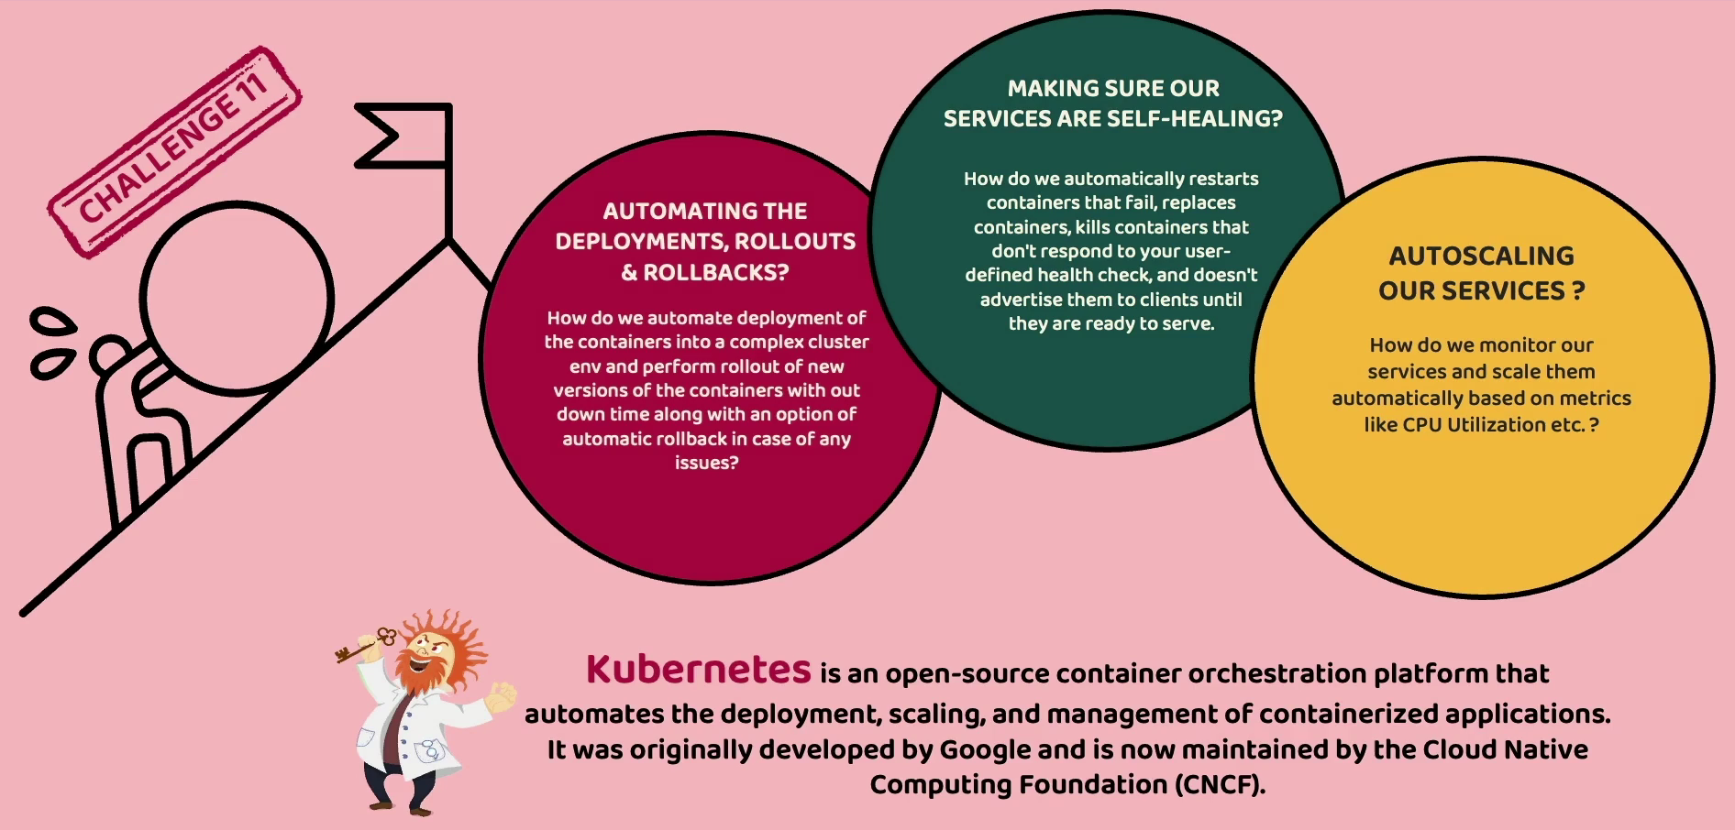

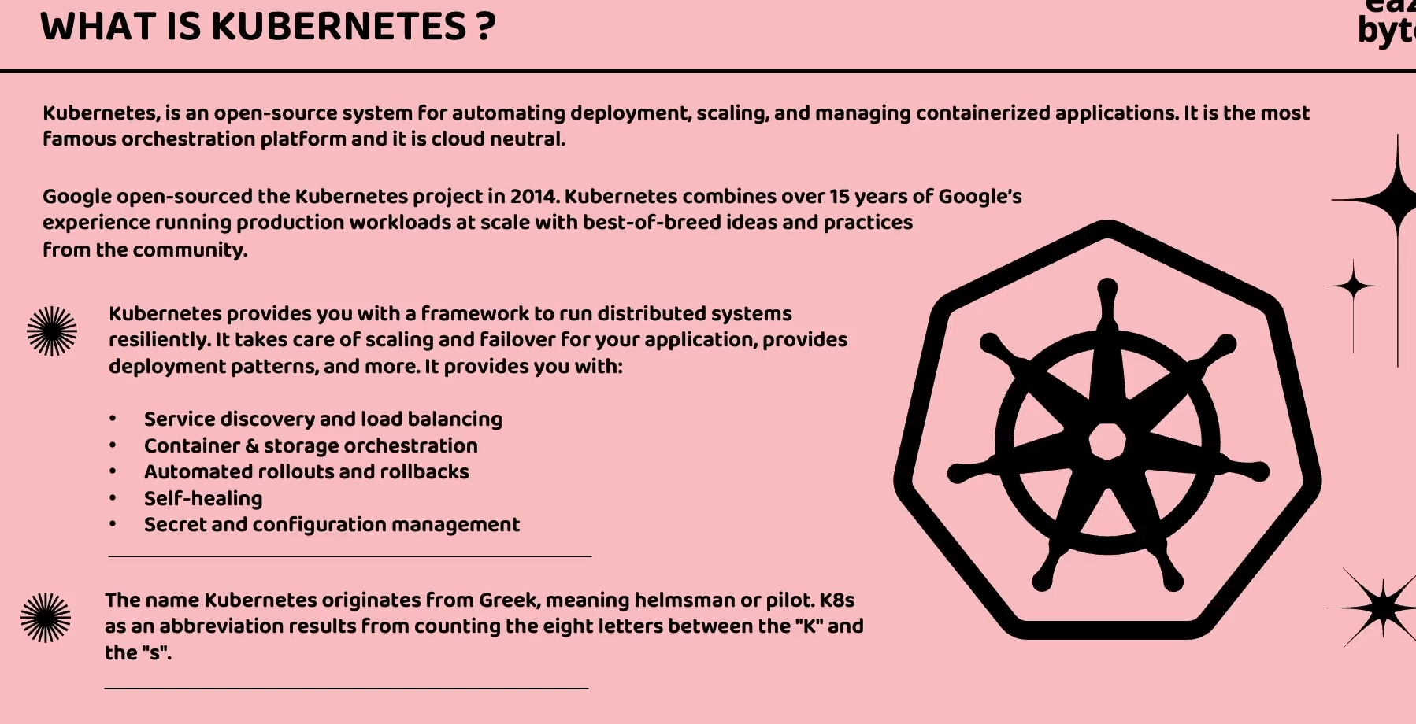

Kubernetes has advantages over docker as lot of manual work is required. While Kubernetes automates deployment, scaling, service discovery and many other

Kubernetes internal architecture 

Kubernetes is also the cluster. Cluster contains a set of servers or virtual machines which are going to work together to make our microservices always running properly. Now we may have question that why don’t we use docker compose to deploy all our microservices. But in real world scenario there may be hundreds of microservices which becomes tedious task deploy in single server (docker host)which may have some limitations. Where we can build multi distributed environment where we deploy our microservices in various server nodes inside server cluster

There are 2 types of nodes in Master node which maintains the entire Kubernetes cluster and worker node.

Worker nodes are responsible to handle incoming client requests.

**Master node** contains kube API Server this is going to expose some API endpoints which can be accessed from anyone from outside Kubernetes cluster to interact with master node and also worker node. We can interact with these nodes using two approaches either by ui admin or CLI. From CLI we can execute some kubectl commands and these commands will be input to kube API server. Also with yaml configuration we can provide set of instructions to Kubernetes saying we want to deploy so and so services with so many replicas . So all these details can be provided as an input details inside a yaml configuration to master node with the help of CLI or admin ui.

**Scheduler** is the responsible to identify in which worker node the service needs to deployed. So behind the scenes it will do a lot of calculations like which worker node has bandwidth which nodes are busy based on the result it will do deploy the microservice.

This information is sent back to control manager so it is responsible of the control manager to always track of the containers and worker nodes if there is any issue then controller manager makes sure of bringing new containers or new worker nodes. So if any container has probm then it is going to kill that container and start the new one.

Another important component is etcd it acts as a brain of the Kubernetes cluster bcoz it is going to act as a Db. It stores the values in the form of key value pair. Controller manager gets all the information from etcdb about how many instances of microservices need to be created. With help of admin UI or CLI cluster is going to make an entry in the etcd

In worker node also we have very important components

Kubelet is responsible for communicating with kube API server that receives the set of the instructions about microservices deployment

Since we are going to deploy all our microservice in the form of containers we need to make sure container runtime environment is Docker. Hence all worker nodes have Docker.

Another important component is pods it acts as a deployment unit. pods are responsible for providing the isolated environment to the containers. Basically each pod will be having single container running that is if there are multiple containers like accounts,cards or loans then they are deployed in separate pods. Hence one pod is dedicated to only one specific container.

Deploy Kubernetes locally

Installing Kubernetes using Docker desktop on local set up we have only single node setup that is both master node and worker node can act as single node due to lot resources needed. But on cloud we can create more than one nodes

<https://docs.docker.com/desktop/kubernetes/>

Now setup the kubectl command which is required to communicate with the master node

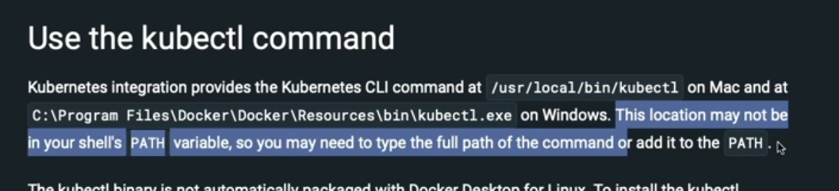

We need to set up path variable in environment variables

Once the setup is done you can run the Kubernetes based commands in cmd

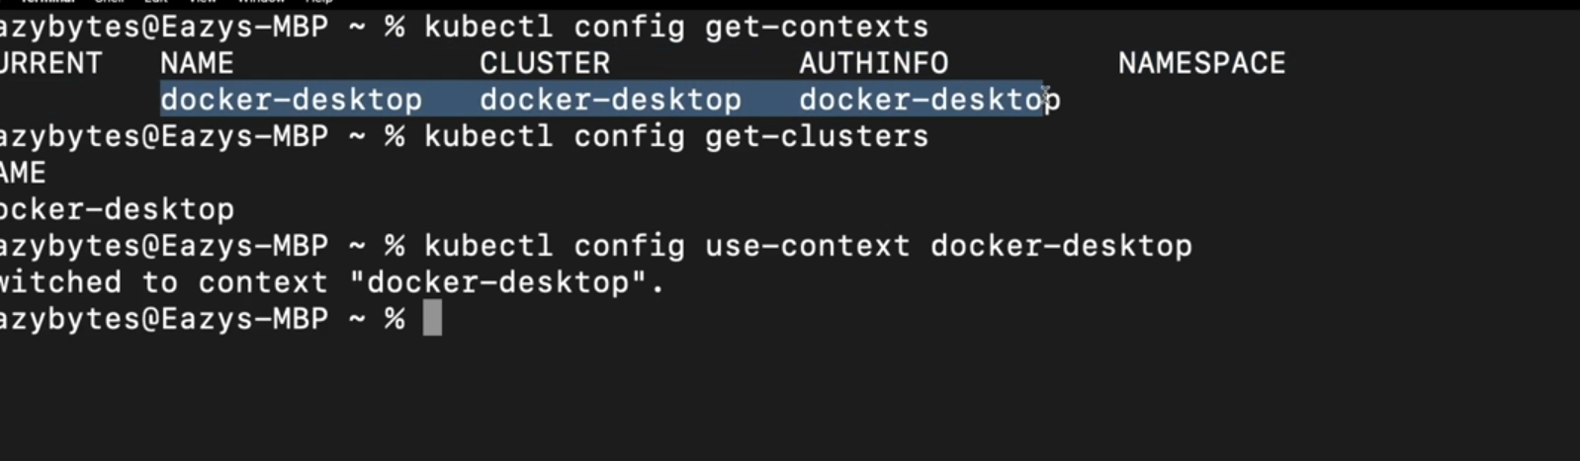

Deploying Kubernetes UI dashboard

<https://kubernetes.io/docs/tasks/access-application-cluster/web-ui-dashboard/>

Goto the above URL and goto section Deploying the Dashboard. Kuberenetes supports only Helm based installation.

Check video 221 for installation.

First we need to install Helm. Helm is package manager to manage Kubernetes related installations

To install helm we need to goto official website of the helm then get started and check installing helm on left menu.

To install helm on windows OS we have to install a chocolatey goto website and click install select individual

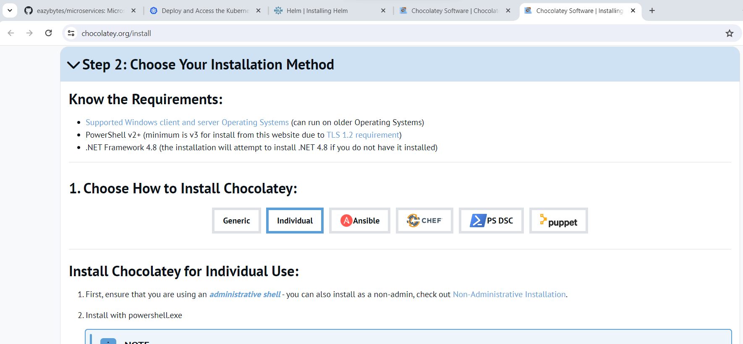

Then run below commands to install UI dashboard available on Kubernetes official web site

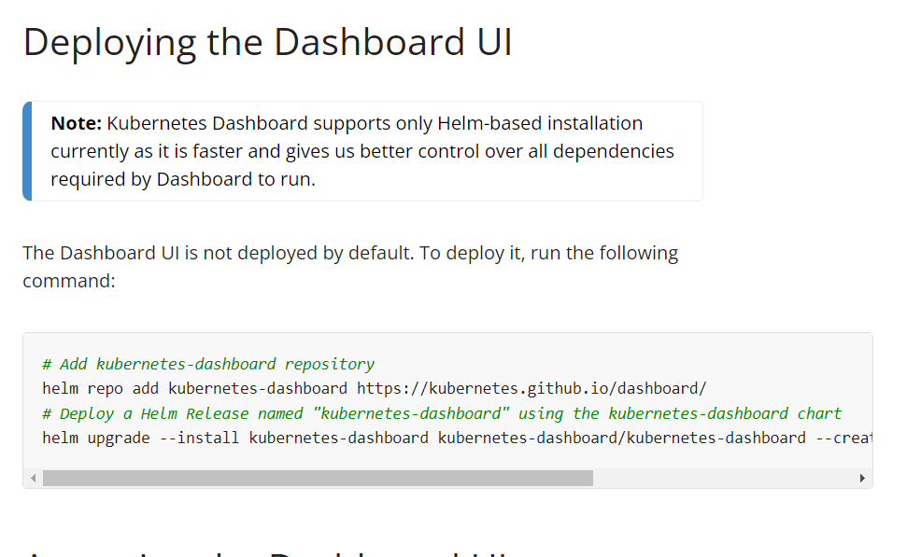

*# Add kubernetes-dashboard repository*

helm repo add kubernetes-dashboard <https://kubernetes.github.io/dashboard/>

*# Deploy a Helm Release named "kubernetes-dashboard" using the kubernetes-dashboard chart*

helm upgrade --install kubernetes-dashboard kubernetes-dashboard/kubernetes-dashboard --create-namespace --namespace kubernetes-dashboard

after executing above command we can see below screen

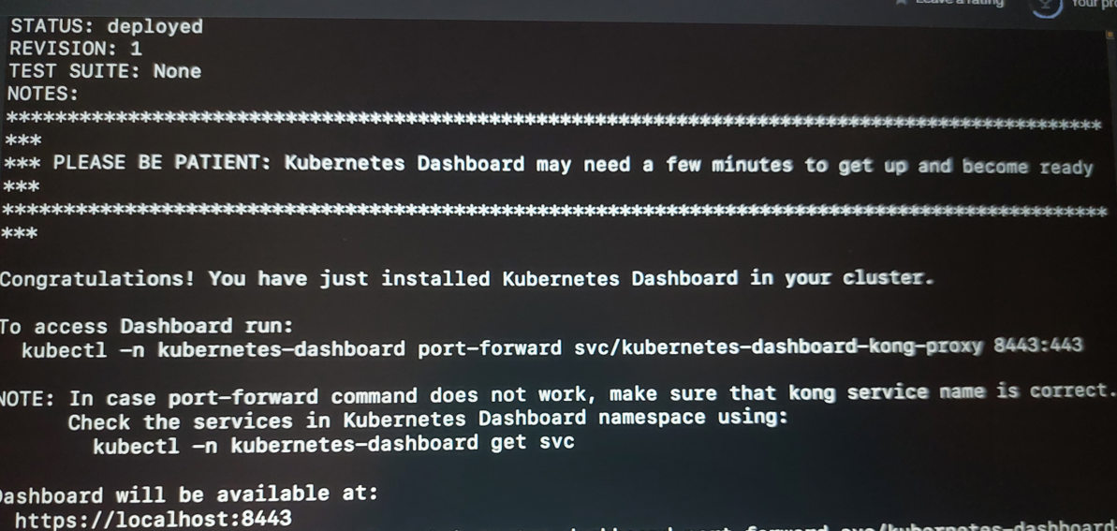

You can access at localhost 8443

Once the installation is done then run helm -version in cmd to check the current version

then run the commands to start the UI dashboard. To access Dashboard we also need to login which requires token.

We need to create service account then click on create sample user link present in the website which will take you to the github. There are instructions provided to create the user

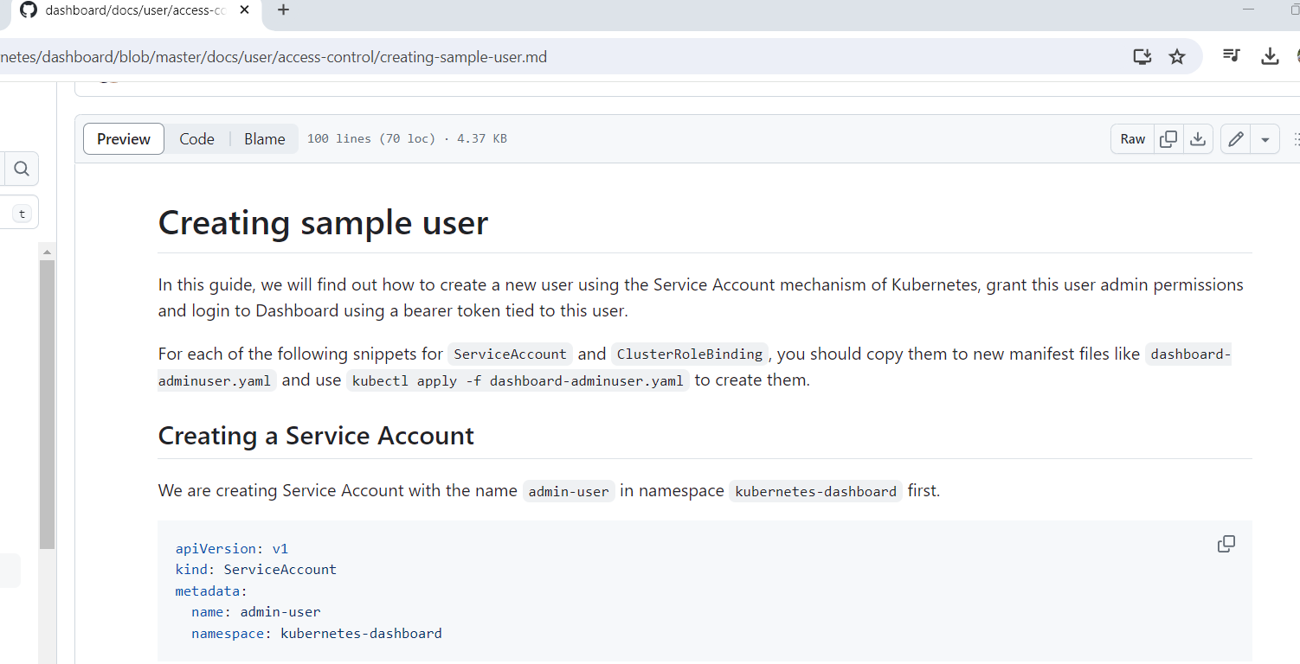

ServiceAccount is an credential that we are trying to create to an particular user

apiVersion: v1

kind: ServiceAccount (Its an predefined object in the Kubernetes cluster)

metadata:

name: admin-user (name provided to the account)

namespace: kubernetes-dashboard (it is an boundry area inside cluster like QA environment/UAT environment)

we need to copy these in adminuser.yaml file create this file on our local system

Now run these yaml file

kubectl apply -f dashboard-adminuser.yaml

And for privileges related information we need to create ClusterRoleBinding

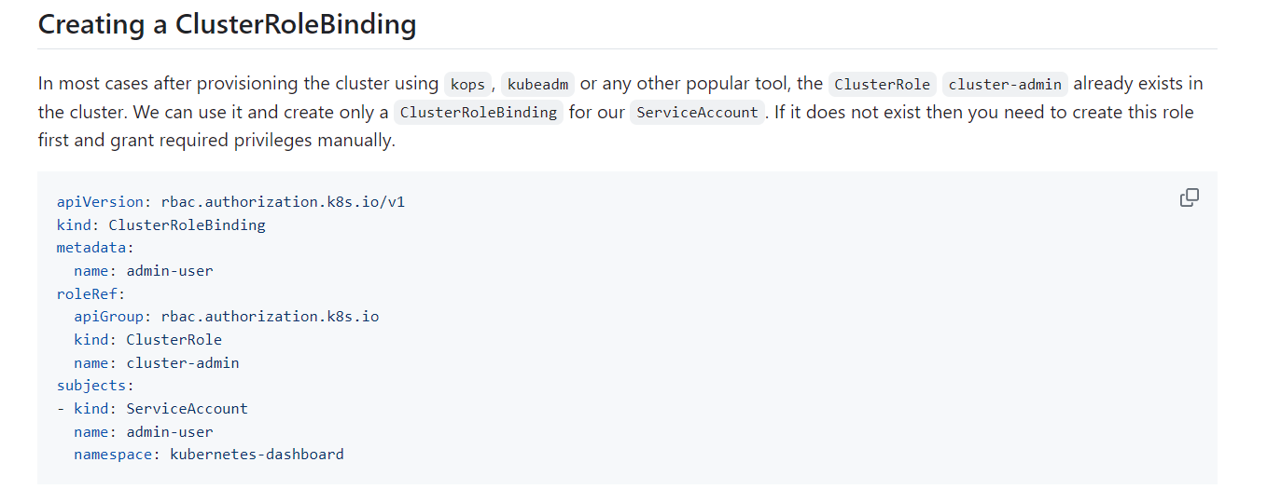

Create a file dashboard-rolebinding.yaml file add the instructions name and namespace should be same as ServiceAccount

kubectl apply -f dashboard-rolebinding.yaml.yaml

Then you will be able to generate a token using below command

kubectl -n kubernetes-dashboard create token admin-user

Now lets configure the Kubernetes to deploy the microservices and how to expose them. So all this information we need to provide in config file. We cannot use the Docker compose configuration bcoz Kubernetes doesnot understand it. Kubernetes has its own format

First will try to deploy config server (section_15)

Lets first create an configserver.yaml file this is usually created by DevOps team

<https://github.com/eazybytes/microservices/blob/3.2.3/section_15/kubernetes/3_configserver.yml>

apiVersion: apps/v1

kind: Deployment (Its predefined object in Kubernetes cluster which instructs to deploy our service)

metadata:

name: configserver-deployment (This is name given to deployment so that this can be uniquely identified)

labels:

app: configserver (Application name)

spec: (This is the specifications that we need to provide to the Kubernetes)

replicas: 1 (Number of instances of application)

selector:

matchLabels:

app: configserver (For which application is this the specification)

template: (We want to specify how this application will be deployed)

metadata:

labels:

app: configserver

spec:

containers: (By default kuberenetes will download the images from docker hub if there is any other repo then we can mention in image with full URL, based on this Kubernetes is going to deploy this container in pods and pod will be created in one of the workers node, In some scenarios there may be requirement of helper container hence list of containers is provided)

- name: configserver

image: eazybytes/configserver:s12

ports:

- containerPort: 8071

--- (these three hyphens indicates that to treat this file as two separate yaml files so before and after this will be treated as different yaml files and kubernetes is going to execute this one by one)

Now to expose this container we need to create a one more object called service as below

apiVersion: v1

kind: Service (This is an inbuilt object which indicates that this microservice is a kind of service )

metadata:

name: configserver (This should be same name as application name and inter communication happens with this name only so this act as a host name)

spec:

selector:

app: configserver (Should be same as specified in deployment)

type: LoadBalancer

ports:

- protocol: TCP

port: 8071 (This is exposed to the public )

targetPort: 8071 (This is where our container is going to start in the Kubernetes network)

In kubernetes configuration files is called manifest files

Now lets run these yaml files but before that will check if there are any deployments to check we can run below command

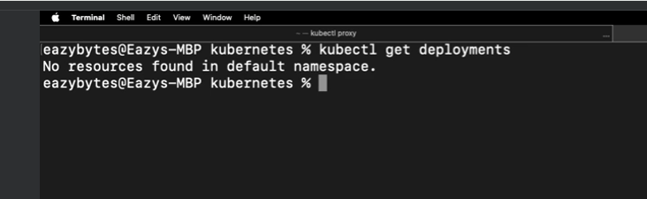

Similarly we can also check for the services

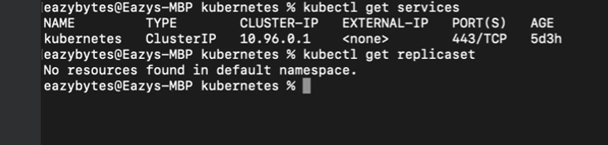

As of now there is no service related to microservice running

We can also confirm this on UI dashboard

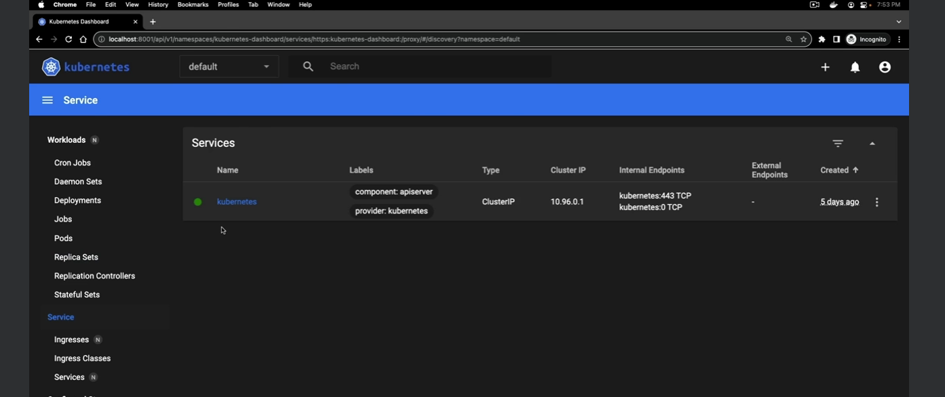

Now goto cmd then navigate to path configserver.yaml and run this yaml file

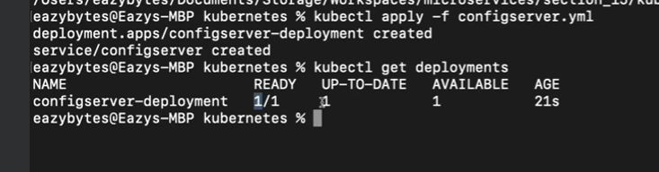

Now run below command to get the information about the service

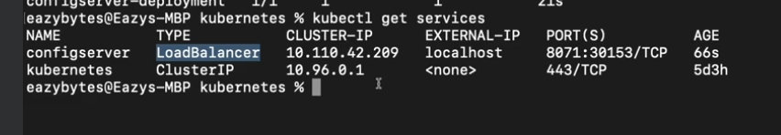

Here cluster IP is an internal network IP and is not exposed to external world while value in External-IP will be exposed to outside world. As of now it is showing the localhost bcoz localhost it is running on localhost if we can deploy it on AWS, GCP cloud environment then it will have real IP address

Now you can check in pods on left hand side

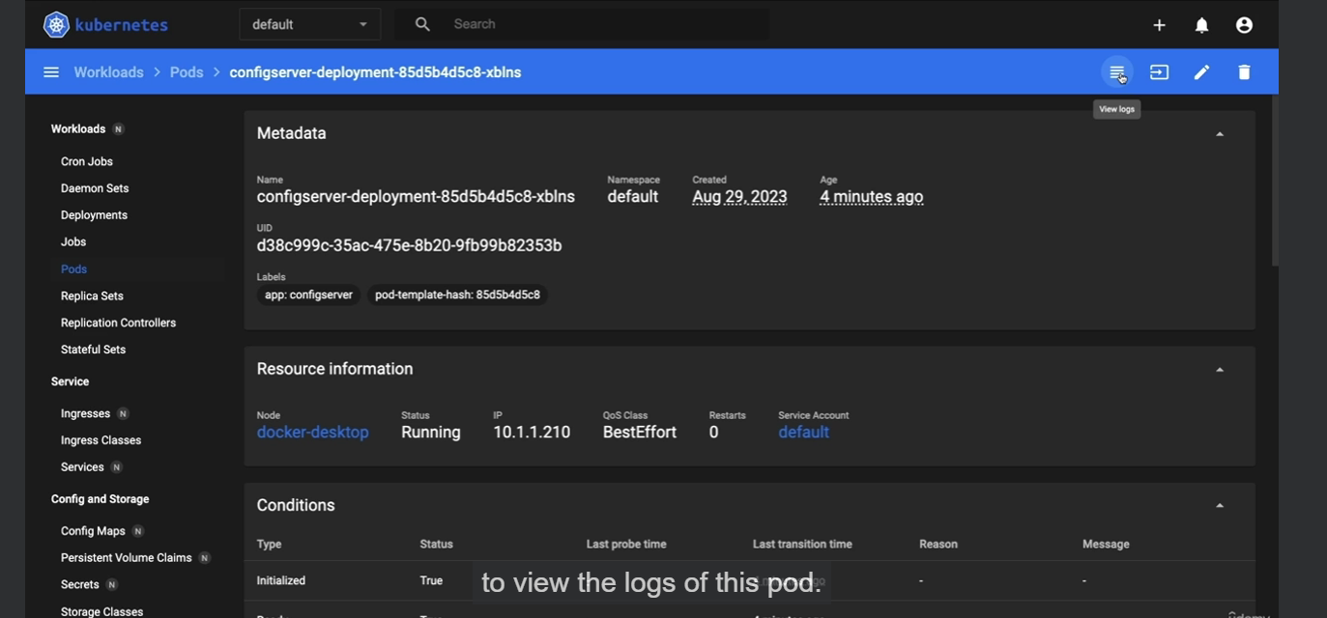

<https://github.com/eazybytes/microservices/blob/3.2.3/section8/docker-compose/default/common-config.yml>

Earlier we were using docker compose file to run the containers which required lot of Environment variables that were passed during run time as example you can check in common config file which are in caps

Since Kubernetes doesn’t supports docker compose file we need to set these Environment variables inside the cluster using the configmaps

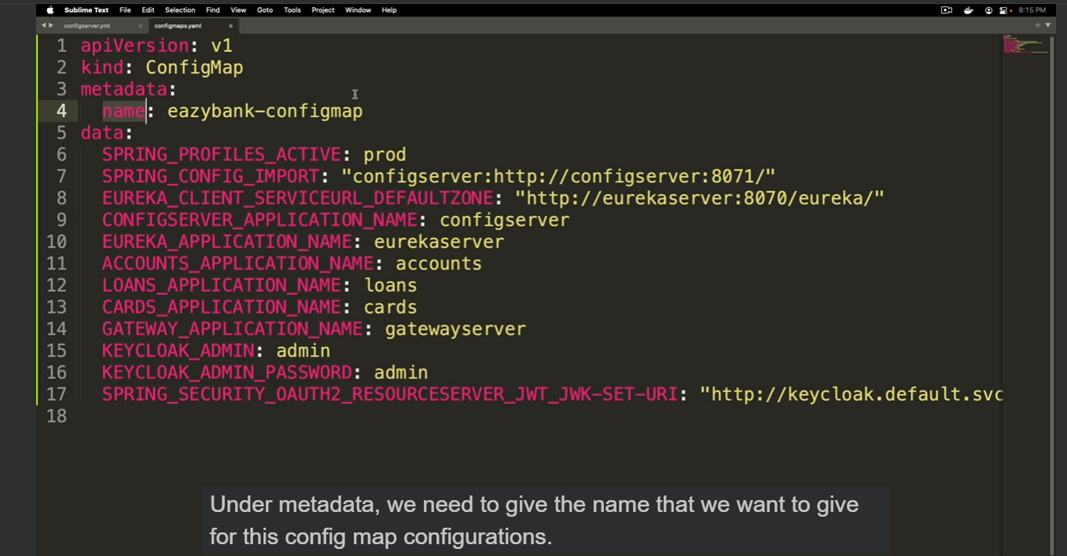

Then apply this configuration file to the

Kubectl apply -f configmaps.yaml

Now to use these env variables we can define this in other config files for eg for eureka server env : name for this we need to set valueFrom where it will fetch from configmap and key used EUREKA_APPLICATION_NAME

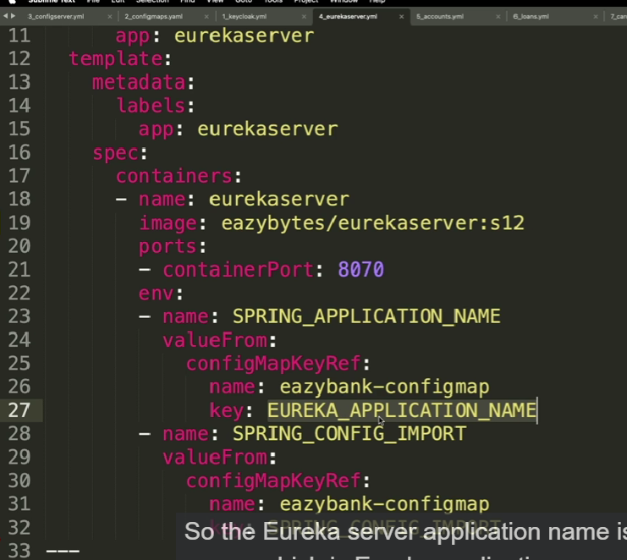

Now lets apply all the manifest files

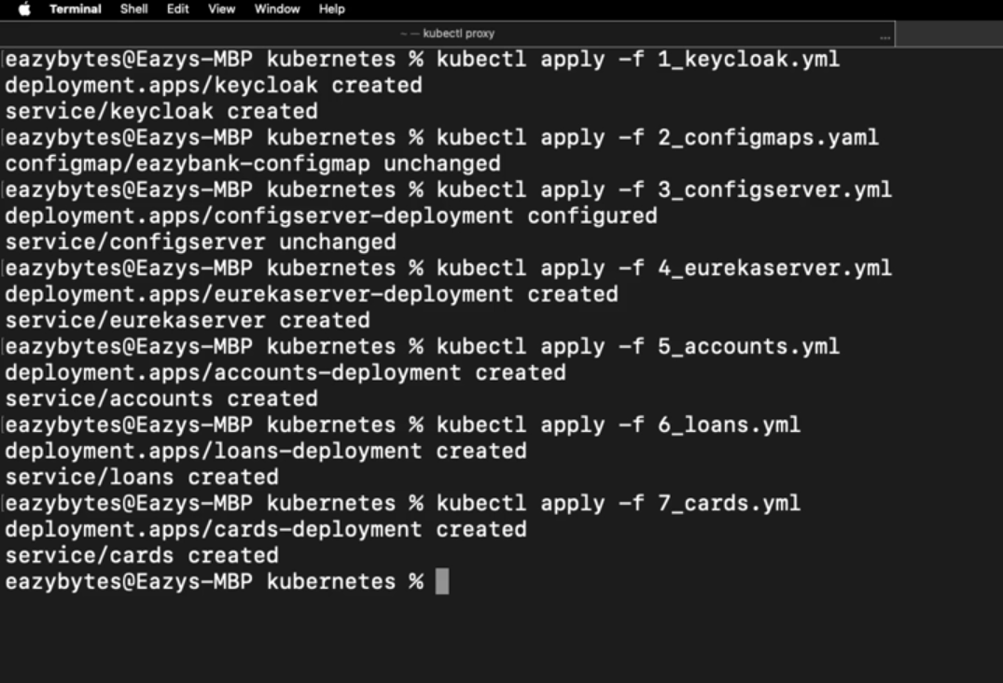

Unlike docker compose Kubernetes doesn’t wait for the microservices to start. So we need to wait until all the dependent microservices have started and then apply all other manifest files